Knowledge Dimension
- We do not adhere to a simple behaviorist view that knowledge is best represented as an accumulation of associations between stimuli and responses (although some surely are) or merely a quantitative increase in bits of information (a hallmark of the empiricist tradition-see Case, 1998; Keil, 1998).
- Rather, our perspective reflects the idea that knowledge is organized and structured by the learner in line with a rationalist-constructivist tradition. Reflecting recent cognitive and developmental psychological research (e.g., Case, 1998), however, we also do not adhere to the idea that knowledge is organized in "stages" or in system-wide logical structures as in traditional developmental stage models of thinking (e.g., Piagetian models)
- Our perspective is that knowledge is domain specific and contextualized. Our understanding of knowledge should reflect this domain specificity and the role that social experiences and context play in the construction and development of knowledge (Bereiter and Scardamalia, 1998; Bransford, Brown, and Cocking, 1999; Case, 1998; Keil, 1998; Mandler, 1998; Wellman and Gelman, 1998)

Categories of the Knowledge Dimension
- Factual knowledge
- Factual knowledge encompasses the basic elements that experts use in communicating about their academic discipline, understanding it, and organising it systematically.
- Factual knowledge contains the basic elements students must know if they are to be acquainted with the discipline or to solve any of the problems in it.
- Knowledge of terminology
Examples of knowledge of terminology
- Knowledge of the alphabet
- Knowledge of scientific terms (e.g., labels for parts of a cell, names for sub-atomic particles)
- Knowledge of the vocabulary of painting
- Knowledge of important accounting terms
- Knowledge of the standard representational symbols on maps and charts
- Knowledge of the symbols used to indicate the correct pronunciation of words
Points to Note:
- Question 1: How many basic elements will be basic enough? If “minus” or “add,” etc., words are used in a classroom where the teacher is teaching Magnification, can these words be categorised as Factual knowledge?
Answer 1: Yes. Every terminology (Noun) related to the domain that is used to explain a concept will be called Factual knowledge.

- Knowledge of specific details and elements
Examples of knowledge of specific details and elements
- Knowledge of major facts about particular cultures and societies
- Knowledge of practical facts important to health, citizenship, and other human needs and concerns
- Knowledge of the more significant names, places, and events in the news
- Knowledge of the reputation of a given author for presenting and interpreting facts on governmental problems
- Knowledge of major products and exports of countries
- Knowledge of reliable sources of information for wise purchasing

- Conceptual knowledge
  - Conceptual knowledge includes knowledge of categories and classifications and the relationships between and among them, more complex, organised knowledge forms. Conceptual knowledge includes schemas, mental models, or implicit or explicit theories in different cognitive psychological models.
  - For example, a mental model for why the seasons occur may include ideas about the Earth, the sun, the rotation of the Earth around the sun, and the tilt of the Earth toward the sun at different times during the year. These are not just simple, isolated facts about the Earth and Sun but rather ideas about the relationships between them and how they are linked to seasonal changes.
- Knowledge of classifications and categories
Examples of knowledge of classifications and categories
- Knowledge of the variety of types of literature
- Knowledge of the various forms of business ownership
- Knowledge of the parts of sentences (e.g., nouns, verbs, adjectives)
- Knowledge of different kinds of psychological problems
- Knowledge of the different periods of geological time

- Knowledge of principles and generalizations
Examples of knowledge of principles and generalizations
- Knowledge of major generalizations about particular cultures
- Knowledge of the fundamental laws of physics
- Knowledge of the principles of chemistry that are relevant to life processes and health
- Knowledge of the implications of American foreign trade policies for the international economy and international goodwill
- Knowledge of the major principles involved in learning
- Knowledge of the principles of federalism
- Knowledge of the principles that govern rudimentary arithmetic operations (e.g., the commutative principle, the associative principle)

- Knowledge of theories, models, and structures
Examples of knowledge of theories & models, and structures

- Knowledge of the interrelationships among chemical principles as the basis for chemical theories
- Knowledge of the overall structure of Congress (i.e., organization, functions)
- Knowledge of the basic structural organization of the local city government
- Knowledge of a relatively complete formulation of the theory of evolution
- Knowledge of the theory of plate tectonics
- Knowledge of genetic models (e.g., DNA)
Points to Note:
- Question 1: What type of Knowledge occurs if a teacher is giving analogies to explain a concept?
- Answer 1: It is Conceptual Knowledge
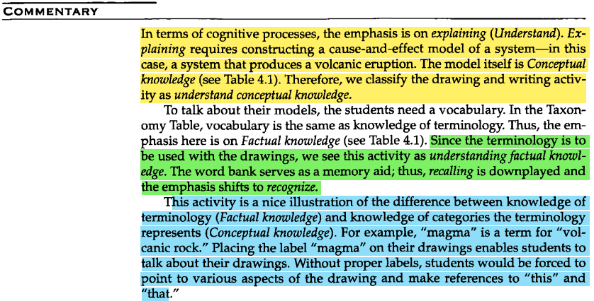
Examples from encoding done for Volcanoes? Here? Vignette(p220) given in Taxonomy Book [5]

- Procedural knowledge
  - Procedural knowledge is the "knowledge of how" to do something. The "something" might range from completing fairly routine exercises to solving novel problems.
- Procedural knowledge often takes the form of a series or sequence of steps to be followed. It includes knowledge of skills, algorithms, techniques, and methods, collectively known as procedures (Alexander, Schallert, and Hare, 1991; Anderson, 1983; deJong and Ferguson-Hessler, 1996; Dochy and Alexander, 1995). Knowledge of subject-specific skills and algorithms.

- Examples of knowledge of subject-specific skills and algorithms
- Knowledge of the skills used in painting with watercolors
- Knowledge of the skills used to determine word meaning based on structural analysis
- Knowledge of the various algorithms for solving quadratic equations
- Knowledge of the skills involved in performing the high jump

- Knowledge of subject-specific techniques and methods
Examples of knowledge of subject-specific techniques and methods
- Knowledge of research methods relevant to the social sciences
- Knowledge of the techniques used by scientists in seeking solutions to problems
- Knowledge of the methods for evaluating health concepts
- Knowledge of various methods of literary criticism

- Knowledge of the criteria for determining when to use appropriate procedures
Examples of knowledge of the criteria for determining when to use appropriate procedures
- Knowledge of the criteria for determining which of several types of essays to write (e.g., expository, persuasive)
- Knowledge of the criteria for determining which method to use in solving algebraic equations
- Knowledge of the criteria for determining which statistical procedure to use with data collected in a particular experiment
- Knowledge of the criteria for determining which technique to apply to create a desired effect in a particular watercolor painting
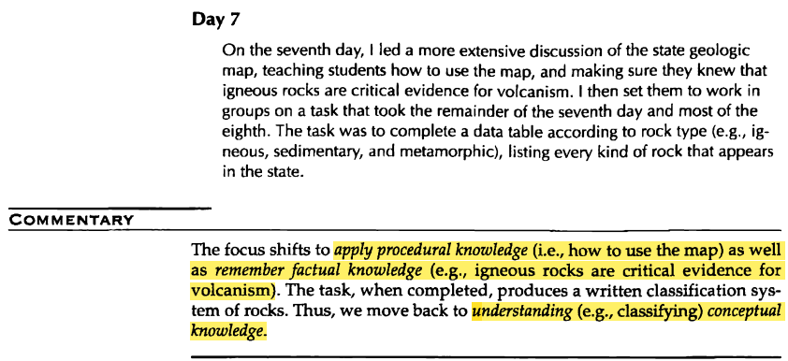
Examples from the encoding done for “Volcanoes? Here?” Vignette (p 220) given in Taxonomy Book [5]

- METACOGNITIVE KNOWLEDGE
  - Metacognitive knowledge is knowledge about cognition in general as well as awareness of and knowledge about one's own cognition.
- Strategic knowledge
Examples of strategic knowledge
- Knowledge that rehearsal of information is one way to retain the information
- Knowledge of various mnemonic strategies for memory (e.g., the use of acronyms such as Roy G Biv for the colors of the spectrum.)
- Knowledge of various elaboration strategies, such as paraphrasing and summarizing
- Knowledge of various organizational strategies such as outlining or diagramming ·
- Knowledge of planning strategies such as setting goals for reading
- Knowledge of comprehension-monitoring strategies such as self-testing or self-questioning
- Knowledge of means-ends analysis as a heuristic for solving an ill-defined problem
- Knowledge of the availability heuristic and the problems of failing to sample in an unbiased manner

- Knowledge about cognitive tasks, including contextual and conditional knowledge.
Examples of knowledge about cognitive tasks, including contextual and conditional knowledge
- Knowledge that recalls tasks (i.e., short-answer items) generally makes more demands on the individual's memory system than recognition tasks (i.e., multiple-choice items)
- Knowledge that a primary source book may be more difficult to understand than a general textbook or popular book
- Knowledge that a simple memorization task (e.g., remembering a phone number) may require only rehearsal
- Knowledge that elaboration strategies like summarizing and paraphrasing can result in deeper levels of comprehension
- Knowledge that general problem-solving heuristics may be most useful when the individual lacks relevant subject- or task-specific knowledge or in the absence of specific Procedural knowledge
- Knowledge of the local and general social, conventional, and cultural norms for how, when, and why to use different strategies

- Self-Knowledge
Examples of self-knowledge

- Knowledge that one is knowledgeable in some areas but not in others
- Knowledge that one tends to rely on one type of "cognitive tool" (strategy) in certain situations
- Knowledge of one's capabilities to perform a particular task that is accurate, not inflated (e.g., overconfident)
- Knowledge of one's goals for performing a task
- Knowledge of one's personal interest in a task
- Knowledge of one's judgments about the relative utility value of a task

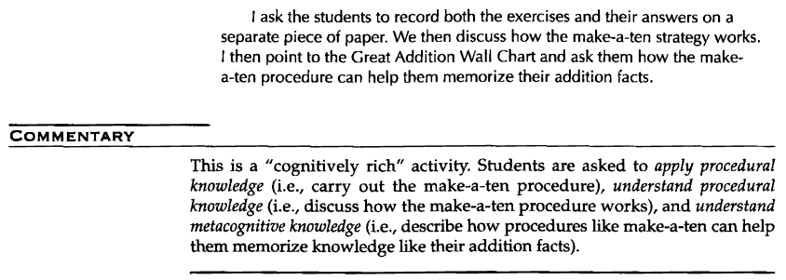
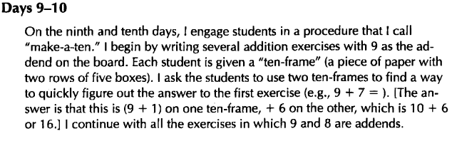
Examples from encoding explained for Addition Facts Vignette(p188) given in Taxonomy Book [5]

Important Points to Note
- We do not adhere to a simple behaviorist view that knowledge is best represented as an accumulation of associations between stimuli and responses (although some surely are) or merely a quantitative increase in bits of information (a hallmark of the empiricist tradition-see Case, 1998; Keil, 1998).
- Rather, our perspective reflects the idea that knowledge is organized and structured by the learner in line with a rationalist-constructivist tradition. Reflecting recent cognitive and developmental psychological research (e.g., Case, 1998), however, we also do not adhere to the idea that knowledge is organized in "stages" or in system-wide logical structures as in traditional developmental stage models of thinking (e.g., Piagetian models)
- Our perspective is that knowledge is domain specific and contextualized. Our understanding of knowledge should reflect this domain specificity and the role that social experiences and context play in the construction and development of knowledge (Bereiter and Scardamalia, 1998; Bransford, Brown, and Cocking, 1999; Case, 1998; Keil, 1998; Mandler, 1998; Wellman and Gelman, 1998)
- A distinction between factual and conceptual knowledge: For classification purposes, Factual knowledge may be distinguished from Conceptual knowledge by virtue of its very specificity; that is, Factual knowledge can be isolated as elements or bits of information that are believed to have some value in and of themselves.
- Sometimes, it is difficult to distinguish knowledge of classifications and categories (2a) from Factual knowledge (1). To complicate matters further, basic classifications and categories can be placed into larger, more comprehensive classifications and categories. In mathematics, for example, whole numbers, integers, and fractions can be placed into the category of rational numbers. Each larger category moves us away from the concrete specifics and into the realm of the abstract
- Assumption 1: We propose that the nature of the Factual and Conceptual knowledge dimension is dynamic rather than static. In a year-long course curriculum of Indian schools, many chapters are linked, and as chapters progress, the conceptual knowledge of one chapter becomes the factual basis for the second chapter, which makes it Factual knowledge for the second chapter. For example, when a teacher is defining, “What is a mirror?” he/she can use the definition,” A highly polished surface, such as a mirror, reflects most of the light falling on it.”(10th class NCERT Science Book, p160) now in the later part the chapter when they are teaching about topic “Magnification” they can use concepts like, “Mirror” and “Spherical mirror” as factual knowledge rather than using them as conceptual knowledge.
- In the taxonomy [5], authors are only defining knowledge as a local dimension; hence the definition of various kinds of knowledge seems static in nature, but in a real classroom scenario (Indian education system) teacher uses previous conceptual knowledge as factual knowledge to build/teach the next conceptual knowledge. This justifies dynamic interaction between Factual and Conceptual knowledge on a global scale.
- Whereas Factual knowledge and Conceptual knowledge represent the "what" and “why” of knowledge, procedural knowledge concerns the "how." In other words, Procedural knowledge reflects knowledge of different "processes," whereas Factual knowledge and Conceptual knowledge deal with what might be termed "products." It is important to note that Procedural knowledge represents only the knowledge of these procedures.
- Subtype 2c (Knowledge of Theories, Models, and Structures) includes knowledge of the different paradigms, epistemologies, theories, and models that different disciplines use to describe, understand, explain, and predict phenomena.
- In contrast to Metacognitive knowledge (which includes knowledge of more general strategies that cut across subject matters or academic disciplines), Procedural knowledge is specific or germane to particular subject matters or academic disciplines. Accordingly, we reserve the term Procedural knowledge for the knowledge of skills, algorithms, techniques, and methods that are subject-specific or discipline-specific. In mathematics, for example, there are algorithms for performing long divisions, solving quadratic equations, and establishing the congruence of triangles.
- Although the concern here is with Procedural knowledge, the result of using Procedural knowledge is often Factual knowledge or Conceptual knowledge. For example, the algorithm for the addition of whole numbers that we use to add 2 and 2 is Procedural knowledge; the answer 4 is simply Factual knowledge. Once again, the emphasis here is on the student's knowledge of the procedure rather· than on his or her ability to use it.
- Strategic knowledge is knowledge of the general strategies for learning, thinking, and problem-solving. The strategies in this subtype can be used across many different tasks and subject matters rather than being most useful for one particular type of task in one specific subject area (e.g., solving a quadratic equation or applying Ohm's law)
- This subtype, 4a, includes knowledge of the variety of strategies that students might use, which can be grouped into three general categories: rehearsal, elaboration, and organizational (Weinstein & Mayer, 1986). Rehearsal strategies involve repeating words or terms to be recalled over and over to oneself; elaboration strategies include the use of various mnemonics for memory tasks, as well as techniques such as summarizing, paraphrasing, and selecting the main idea from texts. Organizational strategies include various forms of outlining, drawing "cognitive maps" or concept mapping, and note-taking; students transform the material from one form to another.
- Students can have knowledge of various metacognitive strategies that are useful in planning, monitoring, and regulating their cognition. Students can eventually use these strategies to plan their cognition (e.g., set subgoals), monitor their cognition (e.g., ask themselves questions as they read a piece of text, check their answer to a math problem), and regulate their cognition (e.g., re-read something they don't understand, go back and "repair'' their calculating mistake in a math problem)
- 4a includes general strategies for problem-solving and thinking (Baron, 1994; Nickerson, Perkins, and Smith, 1985; Sternberg, 1985). These strategies represent the various general heuristics students can use to solve problems, particularly ill-defined problems that have no definitive solution method. Examples of heuristics are means-ends analysis and working backward from the desired goal state. In addition to problem-solving strategies, there are general strategies for deductive and inductive thinking, including evaluating the validity of different logical statements, avoiding circularity in arguments, making appropriate inferences from different sources of data, and drawing on appropriate samples to make inferences (i.e., avoiding the availability heuristic-making decisions from convenience instead of representative symbols).
- 4b. KNOWLEDGE ABOUT COGNITIVE TASKS, INCLUDING CONTEXTUAL AND CONDITIONAL KNOWLEDGE-Students also need to develop conditional knowledge for these general cognitive strategies; in other words, they need to develop some knowledge about the when and why of using these strategies appropriately (Paris, Lipson, and Wixson, 1983). Conditional knowledge refers to knowledge of the situations in which students may use Metacognitive knowledge. In contrast, Procedural knowledge refers to knowledge of the situations in which students may use subject-specific skills, algorithms, techniques, and methods. Certain general learning and thinking strategies are better suited to different tasks. For example, if one confronts a novel problem that is ill-defined, then general problem-solving heuristics may be useful. In contrast, if one confronts a physics problem about the second law of thermodynamics, then more specific Procedural knowledge is more useful and adaptive. An important aspect of learning about strategies is the conditional knowledge of when and why to use them appropriately.
- Metacognitive knowledge is often taught by means of a strategic, often self-regulatory emphasis. In addition, Metacognitive knowledge develops over a lengthy period of time, usually more than a single course or semester.
- Now it may be time to make Metacognitive knowledge manifest. One important result of this change would be the shift from teacher authority in teaching to student empowerment in learning. Metacognitive knowledge enables students to learn to take greater control of their own learning; teachers become facilitators of learning rather than dispensers of knowledge.

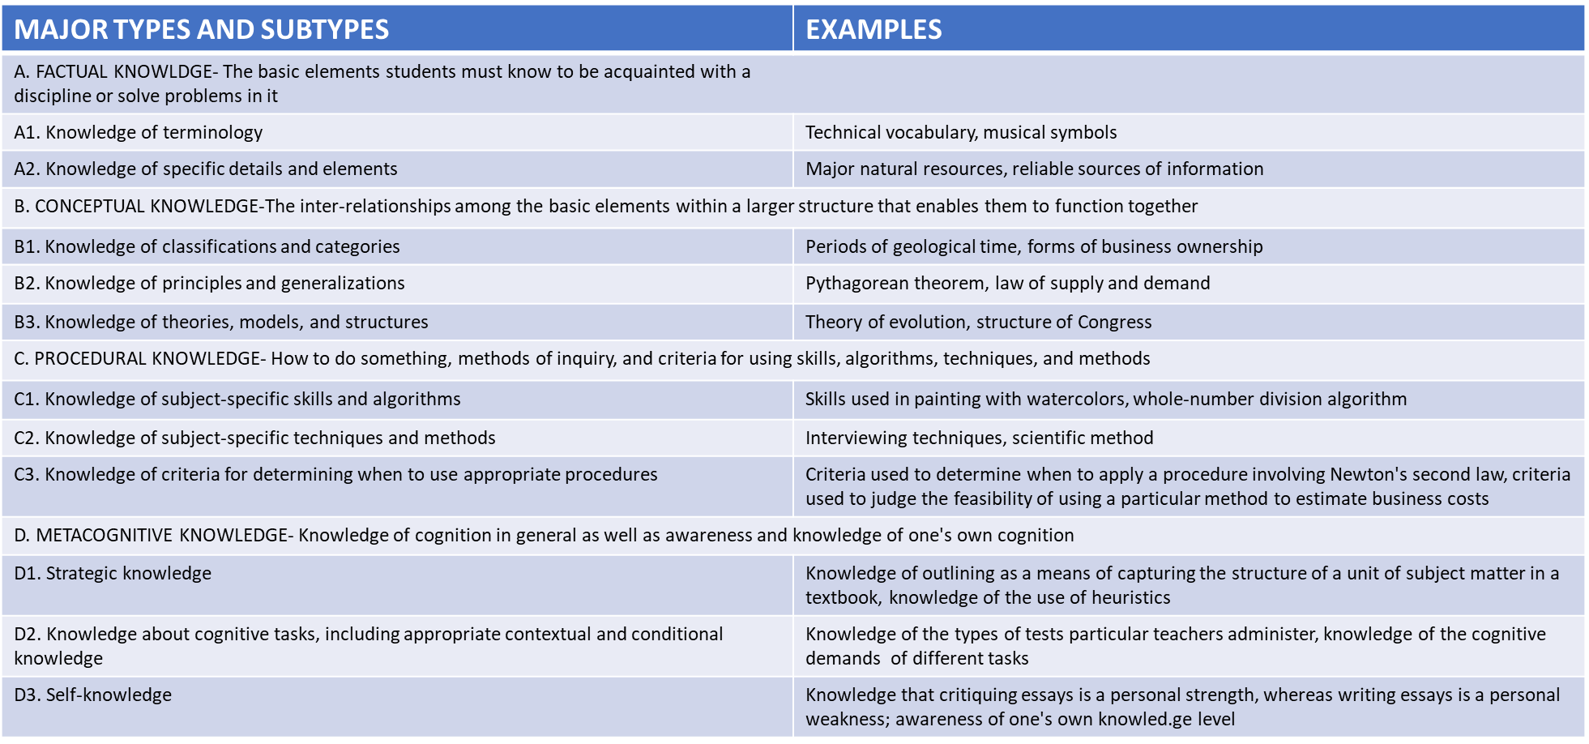
Summary

Operational coding scheme: General heuristics to Identify “Knowledge” type in case of STEM education in the classrooms (6-12) of India
- Knowledge generally occurs as a Noun in a line. So, look for possible Nouns in a sentence.
- Factual knowledge generally occurs as terminologies important for the domain to teach any other type of knowledge. (Topic: Magnification, Possible Factual Knowledge example: Ray diagram, Object height, Image height, Unit of Power, v, u, etc.)
- Conceptual Knowledge generally occurs when the teacher introduces Theories, Principles, Laws, Models, Categories, Meanings, Properties, Analogies, etc. (Newton’s Laws of motion, Work energy theorem, DNA models)
- Please keep Assumption 1 in mind while recognizing factual and conceptual knowledge.
- Procedural Knowledge generally mentions subject-specific skills, algorithms, steps, methods, techniques, criteria of when to choose which method, etc. (Steps to solve quadratic equation, steps to use a divider to measure length of line, criteria of when to use work energy method and when to use Newton law of motion to find velocity of an object)
- Metacognitive is Knowledge of Strategic knowledge, Knowledge about cognitive tasks, including contextual and conditional knowledge, and Self-knowledge. So, it is knowledge of knowledge that is not subject-specific.

More Examples of Metacognitive Knowledge from Vignette
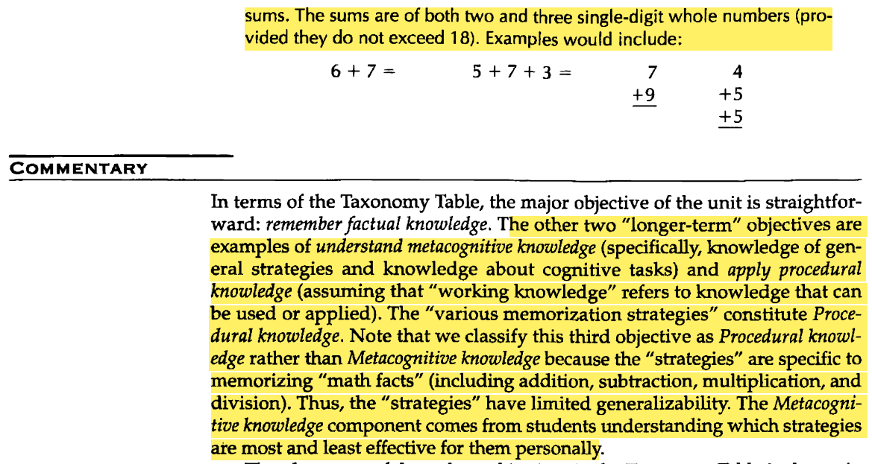
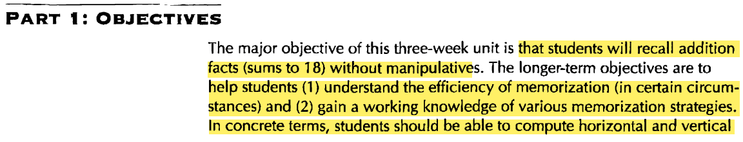
1.

- Other examples of Metacognitive Knowledge from transcription

- In the context of a classroom, the inquiry naturally arises regarding the extent of our focus on metacognitive knowledge (MK) - whether our concern should primarily lie with students' MK or if we should also accord attention to teachers' MK (this is same as MK provided by the teacher to students here.)
- Answer: In a classroom setting, MK can occur in various ways. Student can speak aloud their Mk when the teacher asks them, or the teacher can share some Mk strategies with all students. Both students' metacognitive knowledge (MK) and metacognitive knowledge given by teachers are important considerations.
Students' metacognitive knowledge refers to their understanding and awareness of their own cognitive processes, such as their thinking, learning, and problem-solving strategies. It includes their knowledge of their strengths and weaknesses, their ability to monitor their own comprehension and performance, and their capacity to plan, regulate, and evaluate their learning. Students' MK is crucial because it empowers them to take control of their learning, make effective decisions, and adapt their strategies to optimise their academic performance.
On the other hand, metacognitive knowledge given by teachers plays a vital role in facilitating students' learning. Teachers are aware of the cognitive demands of various tasks and possess strategies to support their students' metacognitive development. They understand how to scaffold learning experiences, provide effective feedback, and promote self-regulated learning among their students. Metacognitive knowledge given by teachers enables them to design appropriate instructional interventions, identify students' learning difficulties, and offer targeted support to enhance students' metacognitive skills.
Therefore, in a classroom, it is important to consider both students' and metacognitive knowledge given by teachers. Students need to develop their own metacognitive abilities to become independent learners, while the metacognitive knowledge given by teachers is used to guide and support their students effectively.

Ambiguities while classifying as Metacognitive knowledge (MK)
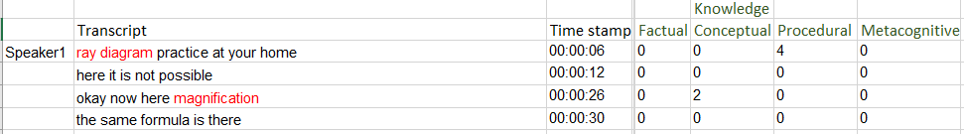
- Question 1: Should the first line (“ray diagram practice at your home”) be marked as MK?
- Answer 1: First, we have to figure out the intent of the teacher. If the intent of the teacher was to discuss the benefits of using rehearsal in general for better memorisation, then it can be marked as MK.
Theoretically, a conversation should happen between student and teacher where the teacher should ask the students about various memorisation strategies students use at home, and some students answer this question by saying they practice at home.
Although, in practice, generally, MK does not occur in the usual ways. Generally, in classroom scenarios, teachers tell students the benefits of the variety of strategies that students might use. These strategies can be grouped into three general categories: rehearsal, elaboration, and organisation (Weinstein & Mayer, 1986).
The reason for this behaviour is that, generally, Indian classrooms are being taught using a teacher-centric approach(behavioristic) rather than a student-centric approach.
Without delineating further and taking a hint from the verb “Practice”, which is a verb related to Applying cognitive process (this strategy is given in the Cognitive Process dimension chapter of the book), we can say the noun “Ray diagram” belongs to PK (Procedural Knowledge).

Operational coding scheme for knowledge dimension

Type of rules | Factual Knowledge (FK) | Conceptual Knowledge (CK) | Procedural Knowledge (PK) | Metacognitive Knowledge (MK)
Decision rules |  | Identify utterances, describing classifications and categories, principles and generalisation, and theories, structure and models | Identify utterances, describing specific skills, algorithms, techniques, methods, or criteria for selecting a procedure. | Knowledge about one’s own cognition, strategies, cognitive tasks, contextual and conditional knowledge, and self-knowledge.
  Identify noun/noun phrases naming domain-specific elements or symbols.
Inclusion criteria |  | - References to theories, laws, principles, models, categories.  - Analogies  - Explanations of relationships (e.g., “as distance increases, magnification decreases”)  - Meaning.  - The use of examples and non-examples  - Newton’s laws of motion, Work-Energy theorem, DNA models | - How to do something or how to choose a method  - Procedures  - Algorithms  - Stepwise instructions (eg. -steps to solve quadratic equations)  - Techniques  - When to use a procedure (criteria for choosing between the work-energy theorem and Newton’s laws) | - Strategy awareness (understanding the efficiency of different strategies like memorisation, rehearsing, summarising, acronyms, etc.)  - Answering short-answer questions requires more effort from memory than MCQs  - Self-knowledge (I excel in physics but struggle with geometry)
  - Domain terminology used as labels (e.g., Lens, Cell, Acid, Integer.
  - Arithmetic terms (e.g., add, minus) when used while explaining.
  - Symbols (α, µ, π), units (kg, km, etc.)
Exclusion criteria |  | If the question being asked requires a factual answer | If only the name of the procedure, algorithm, techniques, etc. mentioned without steps. | If knowledge is subject-specific, it should not be seen as MK
  Non-domain nouns (e.g., classroom nouns like board, chair) are not Factual unless used to teach the concept.
Boundary conditions |  | In a chunk of lines of CK, wherever basic terminologies (eg, mirror, acid, etc.) are used, they should be encoded as both FK and CK. | In a chunk of lines of PK, wherever basic terminologies (eg, mirror, acid, etc.) are used, they should be encoded as both FK and PK. | If the strategy is domain-independent, then MK, and if domain-dependent, then PK
  Very basic terms (e.g., add, minus) are Factual only when used as part of meaning-making for domain content.

